Business Problem
Analyze the data and generate insights that could help Netflix in deciding which type of shows/movies to produce and how they can grow the business in different countries

Problem Statement
- Analyze the distribution of Movies vs TV Shows to determine the optimal content mix for production.
- Identify the most popular genres to guide future content development decisions.
- Evaluate geographical distribution of content to identify key markets and expansion opportunities.
- Examine content release trends over time to understand growth patterns and strategic shifts.
- Analyze content ratings to identify target audience segments and viewing preferences.
- Assess duration and format of content to determine ideal movie lengths and TV show structures.
- Identify frequently occurring actors and directors to support strategic partnerships and collaborations.
Here’s what each column represents in the dataset:

Column | Meaning | Type
show_id | Unique ID for each title | Categorical
type | Movie or TV Show | Categorical
title | Name of the content | Text
director | Director name(s) | Categorical (messy)
cast | Actors | Categorical (multi-value)
country | Production country | Categorical (multi-value)
date_added | When added to Netflix | Date
release_year | Original release year | Numeric
rating | Age rating (TV-MA, PG, etc.) | Categorical
duration | Minutes (movie) or seasons (TV show) | Mixed
listed_in | Genre | Categorical (multi-value)
description | Summary | Text

Exploratory Data Analysis

1. Observations on Basic Metrics
The dataset consists of 8807 rows and 12 columns, indicating a moderately large dataset suitable for content analysis.
- The majority of columns are of type object (11 columns), showing that the dataset is primarily categorical/text-based.
- Only one numerical column (release_year) is present, which is useful for temporal trend analysis.
- Columns such as show_id, title, and listed_in have no missing values, ensuring reliable identification and genre analysis.
- The director column has 2634 missing values (~30%), making it less reliable for complete director-level insights.
- The cast column has 825 missing values (~9%), which may slightly affect actor-level analysis.
- The country column has 831 missing values (~9%), impacting geographical insights.
- The date_added column has only 10 missing values, which is negligible.
- The rating and duration columns have minimal missing values and are largely usable.
- The dataset contains 0 duplicate records, ensuring data integrity.
- The date_added column was converted to datetime format, and year_added and month_added were derived for time-based analysis.
- Columns such as type and rating were converted to categorical data types for efficient processing.

2. Observations from Unique Values (nunique)
- show_id and title have 8807 unique values, confirming each row is a unique title.
- The type column has 2 unique values, clearly distinguishing Movies and TV Shows.
- The director and cast columns have high unique counts, indicating a large variety of contributors.
- The country column has 748 unique values, inflated due to multiple entries per row.
- The date_added column has 1767 unique values, indicating continuous content addition over time.
- The release_year spans 74 unique years, showing content from multiple decades.
- The rating column has 17 unique categories, representing diverse audience segmentation.
- The duration column has 220 unique values, due to mixed formats (minutes and seasons).
- The listed_in column has 514 unique values, inflated due to multiple genres per title.
- The description column has 8775 unique values, meaning most titles have unique summaries.

3. Data Preprocessing & Feature Engineering
- The date_added column was cleaned and converted into datetime format, with year_added and month_added extracted.
- The rating column contained inconsistent values (e.g., duration-like entries) which were identified and cleaned.
- The duration column contained mixed formats and was split into:
  - movie_duration (minutes)
  - show_duration (seasons)
- Multi-valued columns such as cast, country, and listed_in were normalized using show_id to enable granular analysis.

4. Non-Graphical Analysis (Value Counts & Distributions)
- Movies (6131) significantly outnumber TV Shows (2676), indicating a strong focus on movie content.
- The rating distribution is dominated by TV-MA and TV-14, showing focus on mature and young adult audiences.
- The country analysis shows the United States, followed by India and the United Kingdom, as major content contributors.
- The listed_in column shows Dramas, International Movies, and Comedies as the most frequent genres.
- High unique counts in cast and director indicate diversity, with some recurring collaborations.
- Multi-valued columns such as country, cast, and listed_in require preprocessing for accurate analysis.
- Content addition is continuous over time, as seen from the spread in date_added values.

5. Advanced Non-Graphical Insights

👥 Cast Analysis
Actors like Anupam Kher and Shah Rukh Khan appear most frequently, indicating strong representation of Indian cinema.
Presence of voice actors suggests significant contribution from animated and international content.

🎬 Director Analysis
Directors such as Rajiv Chilaka and Jan Suter appear frequently, indicating repeated collaborations.
Presence of global and regional directors highlights Netflix’s diverse content strategy.

🎭 Genre Analysis
International Movies, Dramas, and Comedies dominate overall content.
TV-specific genres such as TV Dramas and International TV Shows are prominent among TV content.
There is a clear separation between Movie and TV Show genres, indicating structured classification.

🌍 Country vs Type Analysis
The United States dominates both Movies and TV Shows, making it the primary content producer.
Countries like India and the United Kingdom contribute mainly to Movies.
Regions such as Japan show stronger representation in TV Shows, indicating regional specialization.

🔀 Genre vs Type Analysis
Movies dominate genres such as Dramas, Comedies, and Action & Adventure.
TV Shows are concentrated in TV-specific genres like TV Dramas and Crime TV Shows.
This reflects Netflix’s strategy of using Movies for broad reach and TV Shows for serialized engagement.

Visual Analysis - Univariate, Bivariate after pre-processing of the data
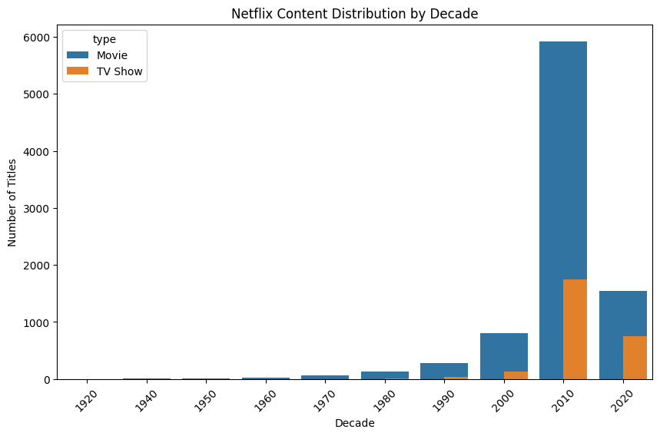
- The distribution shows that Netflix content is heavily concentrated in recent decades, particularly after 2000.
- There is a sharp increase in both Movies and TV Shows after 2010, indicating rapid platform expansion.
- Movies consistently dominate TV Shows across all decades, reflecting a stronger focus on film content.
- TV Shows began to grow significantly only in the 2000s and accelerated further in the 2010s.
- Very limited content exists from earlier decades (pre-1990), highlighting Netflix’s emphasis on modern and recent productions.
- 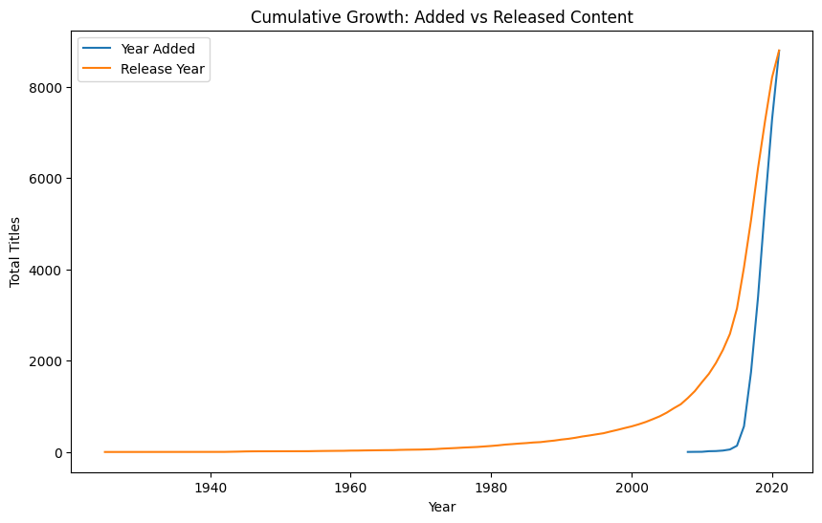

Cumulative Growth: Added vs Released Content
- The cumulative curve for release year shows a steady increase over decades, indicating a large pool of content produced historically.
- The year added curve rises sharply after 2015, highlighting Netflix’s aggressive content acquisition and expansion phase.
- There is a clear lag between content production and its addition to Netflix, especially for older titles.
- The steep growth in recent years suggests a shift toward rapid onboarding of content to the platform.
- By 2020+, both curves converge closely, indicating that newer content is being added to Netflix almost immediately after release.

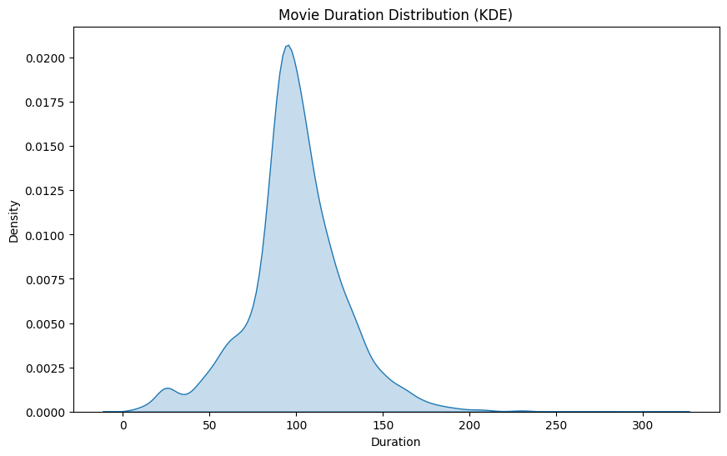

📊 Movie Duration Distribution (KDE)
- The distribution peaks around 90–110 minutes, showing that most movies follow standard industry duration.
- The curve is slightly right-skewed, indicating the presence of longer-duration movies but in smaller numbers.
- Very short movies (<60 min) and very long movies (>150 min) are relatively rare.
- The smooth KDE curve highlights a consistent pattern in movie lengths, suggesting standardization in content production.
- The concentration around ~100 minutes reflects optimal viewer engagement duration preferred by Netflix.

Categorical Variables – Required Charts (Topics Only)
- Content Type Distribution (Movies vs TV Shows)
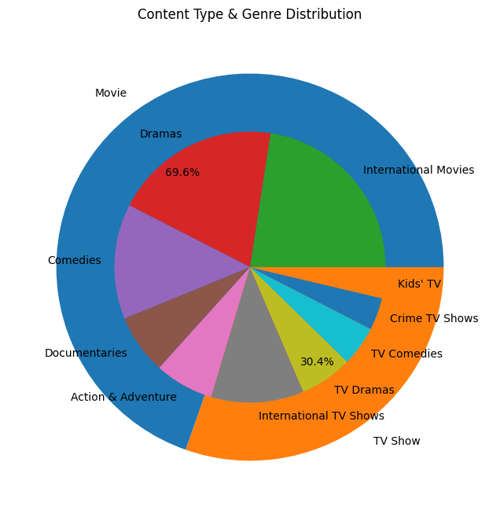
- Movies dominate the overall content distribution, contributing a significantly larger share compared to TV Shows.
- Within Movies, genres like Dramas, International Movies, and Comedies form the largest portion of content.
- TV Shows have a smaller share overall but are concentrated in specific genres such as TV Dramas, International TV Shows, and TV Comedies.
- The genre distribution indicates that Movies cater to a broader range of categories, while TV Shows focus on more specialized, serialized content.
- Overall, the chart highlights Netflix’s strategy of using Movies for volume and variety, while TV Shows are used for targeted audience engagement.

- Rating Distribution (Audience Category Popularity)
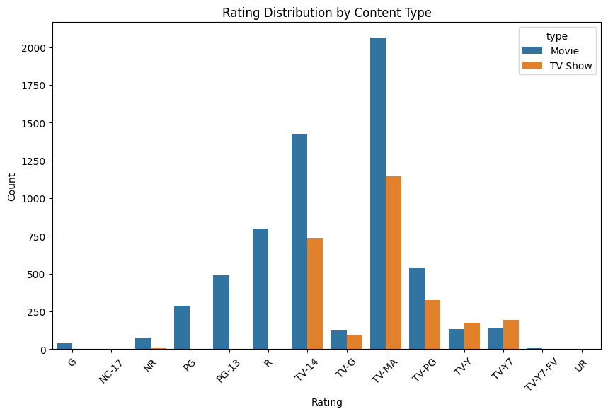
- Dominant Rating: TV-MA is the most frequent rating for both categories, peaking at over 2,000 counts for Movies and approximately 1,100 for TV Shows.
- Volume Difference: Movies significantly outnumber TV Shows across almost all major rating categories, particularly in adult-oriented ratings like TV-14 and R.
- Mature Content Focus: The distribution is heavily skewed toward mature audiences, with TV-MA and TV-14 accounting for the vast majority of the total content library.
- Exclusive Ratings: Certain theatrical ratings, such as PG-13 and R, are almost exclusively populated by Movies, with negligible or zero representation in TV Shows.
- Children’s Programming: For youth-targeted content (TV-Y and TV-Y7), the counts are much lower and more evenly balanced, though TV Shows slightly lead in these specific categories.

- Top 10 Countries (Content Production by Region)
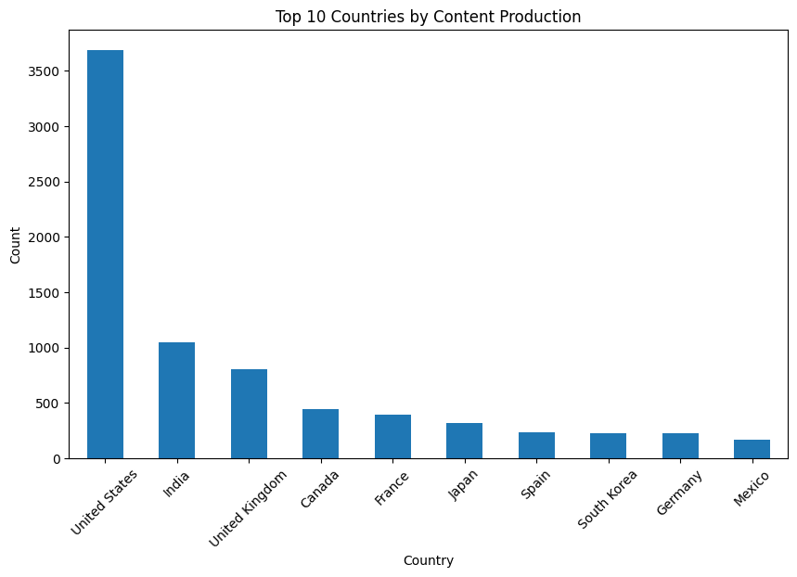
Global Leadership: The United States dominates total content production with over 3,500 titles, followed by India and the United Kingdom, showing a strong preference for Movies in the top two regions.
Production Trends: The data highlights a concentration of talent and production in a few key hubs, with a significant drop-off in volume after the top three producing nations.

- Top 10 Genres (Content Popularity by Category)
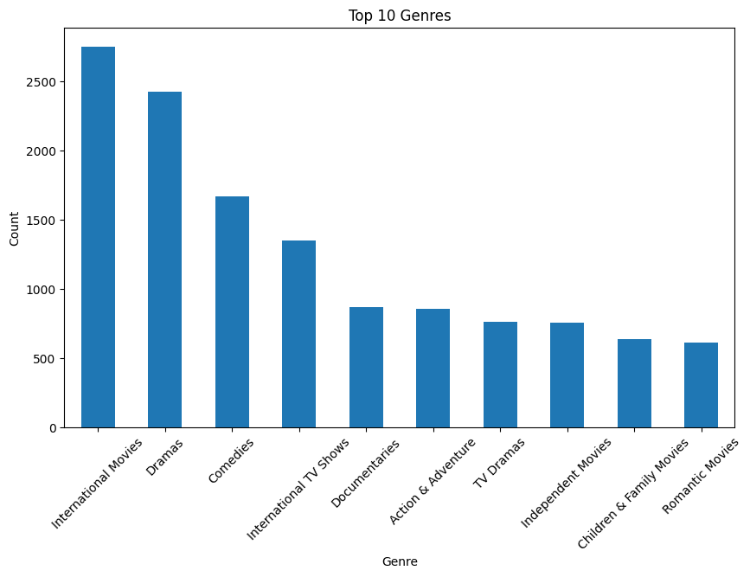

- Top 10 Actors (Most Frequent Cast / Popularity)
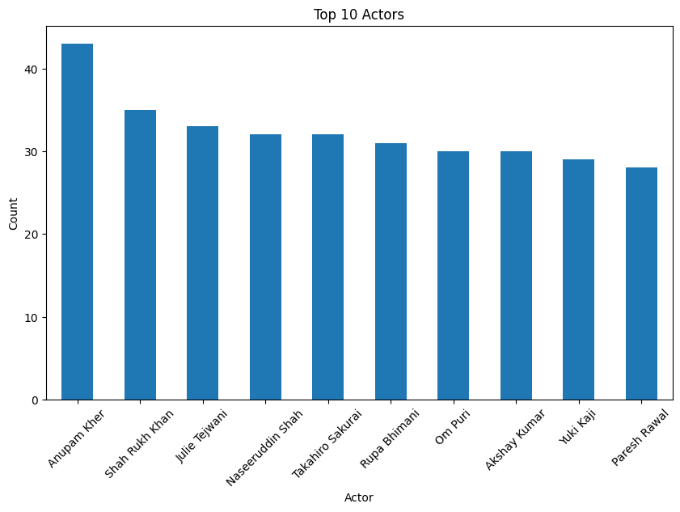
Top Talent: Anupam Kher leads as the most frequent actor with over 40 appearances, while Rajiv Chilaka and Raúl Campos are the most prolific directors in the dataset.

- Top 10 Directors (Frequent Collaborations / Creators)
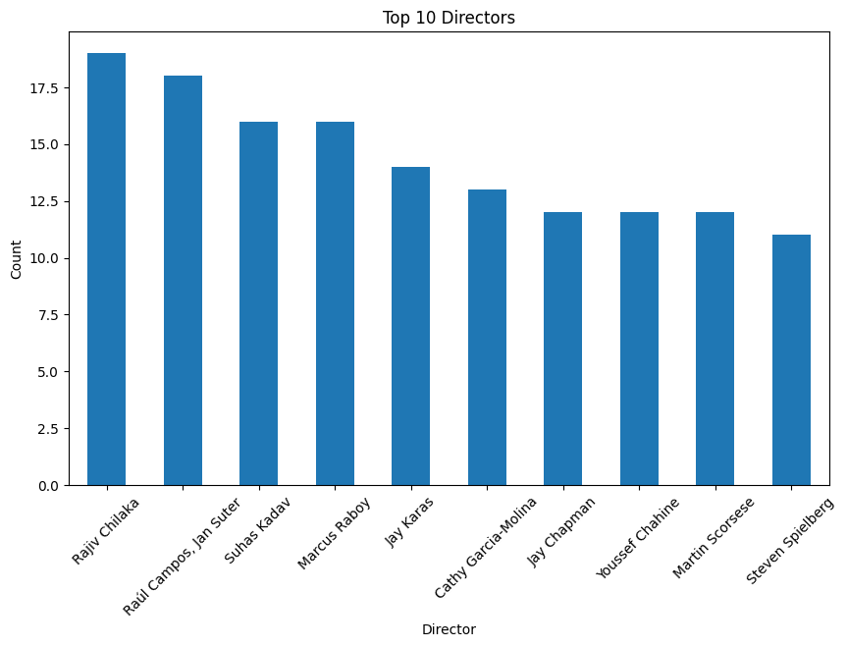

- Country vs Type (Regional Content Strategy)
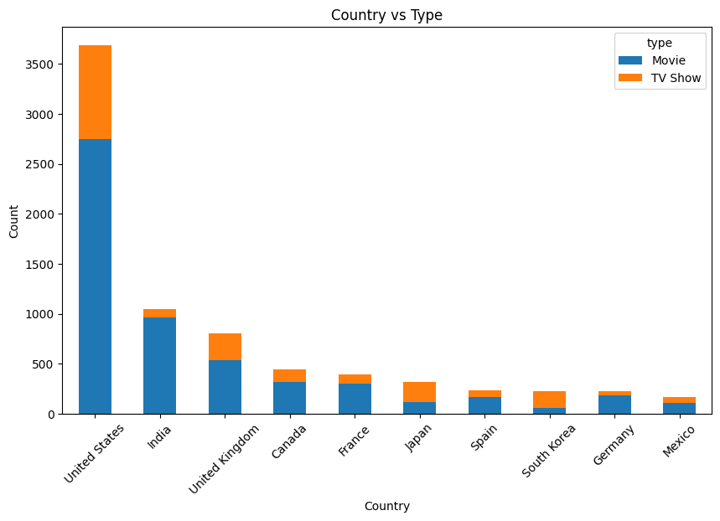
Regional Strategy: While most countries prioritize Movies, South Korea and Japan show a unique regional strategy with a much higher proportion of TV Shows relative to their total output.
- Rating vs Type (Audience Targeting by Content Type)
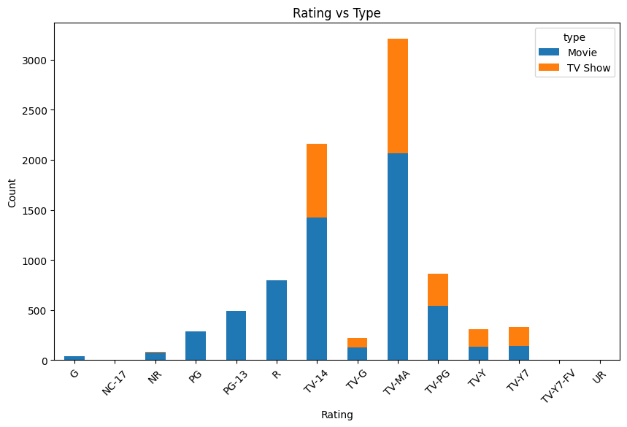
Audience Targeting: Content is heavily skewed toward mature audiences, with TV-MA being the most frequent rating for both Movies and TV Shows, followed closely by TV-14.

📦 Boxplots (Categorical vs Continuous)
- Type vs Movie Duration
- Rating vs Movie Duration

6. Insights based on Non-Graphical and Visual Analysis

6.1 Comments on the Range of Attributes
- The dataset spans 74 years of release_year, indicating a wide temporal coverage from older classics to modern content.
- Movie durations range from ~3 minutes to 300+ minutes, though most are concentrated within standard viewing lengths.
- TV Shows range from 1 to 17 seasons, with the majority having short lifecycles.
- The dataset includes 17 rating categories, covering diverse audience segments from kids to mature viewers.
- The country and genre attributes have a very high range of unique values, mainly due to multiple entries per title.

6.2 Comments on Distribution & Relationships
- The distribution of release_year is heavily skewed toward recent years, indicating a strong focus on modern content.
- Movie duration follows a near-normal distribution centered around ~100 minutes, reflecting industry standards.
- TV Show duration is right-skewed, with most shows having 1–2 seasons and very few long-running series.
- Rating distribution is dominated by TV-MA and TV-14, showing a clear focus on adult and young adult audiences.
- Movies dominate overall content volume, but TV Shows show faster growth in recent years.
- Strong relationships are observed between:
- Genre and Type → Movies dominate general genres, TV Shows dominate specialized categories
- Country and Type → US leads in both, while some countries specialize in TV content
- Rating and Type → Adult ratings are common across both, but more concentrated in Movies

6.3 Comments on Univariate & Bivariate Plots
🔹 Univariate Analysis
- Release Year Histogram / Decade Plot: Shows a sharp increase in content after 2000, with peak production post-2010.
- Movie Duration Distribution (KDE/Histogram): Most movies fall within 90–120 minutes, indicating standardized content length.
- TV Show Duration Plot: Majority of shows have 1–2 seasons, highlighting preference for short series.
- Type Distribution Plot: Movies significantly outnumber TV Shows, showing Netflix’s stronger focus on films.
- Rating Distribution Plot: TV-MA and TV-14 dominate, confirming focus on mature audiences.
- Top Countries Plot: US leads significantly, followed by India and the UK, showing key production markets.
- Top Genres Plot: Dramas, International Movies, and Comedies are the most common genres.
- Top Actors/Directors Plot: A few individuals appear frequently, indicating repeated collaborations.

🔹 Bivariate Analysis
- Genre vs Type (Stacked Bar): Movies dominate most genres, while TV Shows are concentrated in TV-specific categories.
- Country vs Type (Stacked Bar): The US leads in both Movies and TV Shows; some countries show format specialization.
- Rating vs Type (Stacked Bar): Adult ratings dominate both content types, with slight variation across formats.
- Type vs Duration (Boxplot): Movies show a wide spread in duration, while TV Shows are limited to discrete seasons.
- Rating vs Duration (Boxplot): Duration remains relatively consistent across ratings, centered around ~100 minutes.
- Cumulative Growth Plot: Shows rapid increase in content addition after 2015, indicating platform expansion.
7. Business Insights
- Netflix’s catalog is heavily skewed toward recent content (post-2010), indicating a strategy focused on staying relevant with modern audiences rather than relying on older titles.
- Movies dominate the platform in volume, but TV Shows have shown faster growth in recent years, suggesting a shift toward long-term user engagement through series.
- The majority of content is rated TV-MA and TV-14, showing a strong focus on adult and young adult viewers, who are likely the most active streaming audience.
- Short-duration content performs better structurally—most movies are around 90–120 minutes and TV Shows have 1–2 seasons, indicating a preference for easily consumable content.
- The United States leads content production, followed by India and the UK, but there is strong representation from international markets like Japan and South Korea, reflecting global expansion.
- Dramas, Comedies, and International content dominate, highlighting viewer preference for emotionally engaging and culturally diverse storytelling.
- Certain actors and directors appear frequently, indicating that Netflix leverages recurring collaborations to maintain consistent content pipelines.
- A clear separation exists between Movie and TV Show genres, suggesting that Netflix strategically uses Movies for variety and TV Shows for niche, serialized storytelling.
- Content addition has grown rapidly after 2015, showing Netflix’s aggressive expansion and investment phase.
- There is a noticeable lag between release year and addition year for older content, indicating reliance on both new productions and acquired titles.

8. Recommendations
- Increase investment in TV Shows, especially multi-season series, to improve long-term user retention and binge-watching behavior.
- Continue producing content in popular genres like Drama and Comedy, while expanding into underrepresented genres to diversify the catalog.
- Strengthen focus on international markets by creating more region-specific content, especially in high-growth regions like Asia.
- Maintain a strong pipeline of recent and original content to keep the platform competitive and relevant.
- Expand content targeting younger audiences (kids and family) to capture a broader user base.
- Collaborate more with high-performing actors and directors who already have proven audience appeal.
- Focus on producing shorter series (1–3 seasons) to align with viewer consumption patterns and reduce drop-off rates.
- Optimize content duration by keeping movies within the standard 90–120 minute range for better engagement.
- Increase the speed of adding newly released content to the platform to reduce the gap between release and availability.
- Invest in localized storytelling with global appeal, combining regional themes with universal narratives to attract a wider audience.

